Study Material
<Program Code: CO/CM/CW/DE/EJ/ET/EN/EX/EQ/IE/IS/IC/MU>: <Course Code:22320><Course Name: Digital Techniques><Topic Name: Number Systems and code>
<UO1d. 1><study Material>

Course Expert: Mrs Rita Vora | Date:21/07/2020 | Mentor: Mr. K. P. Akole  Co-ordinator: Mrs Nirmala Kamble
Key words  BCD code  BCD Addition | Learning Objective:  To perform BCD Addition | 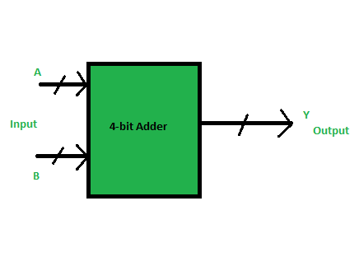  BCD Adder
Key Questions  Q1. Did you know that numbers greater than nine are invalid BCD numbers?  Q2.?State the rules of BCD addition. | Concept Map
 | BCD Code (8421 Code): In BCD 8421 code, each decimal digit is represented using a 4-bit binary number. The 4-bit binary numbers have their weights attached as 8, 4, 2, 1 from MSB to LSB side. Since the weights are attached to it comes in the category of weighted codes and is also sequential.  In a digital system that accepts only binary numbers in form of 0 and 1, the only way to interpret decimal numbers is its conversion from decimal to binary and vice-versa which is a slow process and it also requires a huge electronic circuitry. So, we use BCD numbers. Also, the sequential nature of BCD numbers makes it advantageous for performing arithmetic operations | Key Definitions  BCD code: In this code each decimal digit is represented by a 4-bit binary number.  Numbers greater than 9 are invalid BCD numbers. Give a correction of 6 for converting invalid BCD numbers into valid BCD numbers  .
Solved word Problem

Q1.Add (57)₁₀ and (26)₁₀ using BCD addition.
Solution:
0101 0111
+ 0010 0110
0111 1101
+ 0000 0110
1000 0011

Ans is (83)₁₀
 | Application of 1’s complement method  - ComputerSystems  - Microcontroller and Microprocessor  - Digital Systems  - Alphanumeric Displays  - Financial Application  - Industrial Application  - Commercial Application | Link to YouTube/ OER/ video  https://nptel.ac.in/courses/108/105/108105132/  click on lecture 25  https://www.electrical4u.com/bcd-or-binary-coded-decimal-bcd-conversion-addition-subtraction/

- BCD is a binary code of the ten decimal digits. It is not a binary equivalent.
- In the BCD, with four bits we can represent sixteen numbers (0000 to 1111). But in BCD code only first ten of these are used (0000 to 1001).
- The remaining six code combinations i.e. 1010 to 1111 are invalid in BCD.
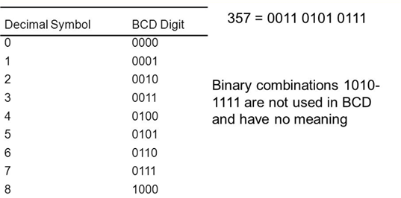
BCD Representation

To perform BCD addition
  - Add the BCD digits as regular binary numbers.
  - If the sum is 9 or less and no carry was generated, it is a valid BCD digit.
  - If the sum produces a carry, the sum is invalid and the number 6 (0110) must be added to the digit.
  - If the sum is greater than nine, the sum is invalid and the number 6 (0110) must be added to the digit.
  - Repeat for each of the BCD digits.

Case 1: Sum is equal to or less than 9 and carry = 0

Case 2: Sum is greater than 9 but carry= 0

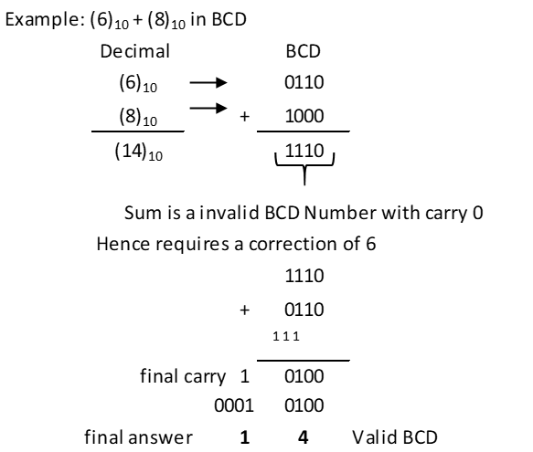

The number 6 is being added to the addition result in the above case instead of any other numbers. It is done to skip the six invalid states of binary coded decimal that is from 10 to 15 and again return to the BCD codes.

Case 3: Sum is less than or equal to 9 but carry = 1
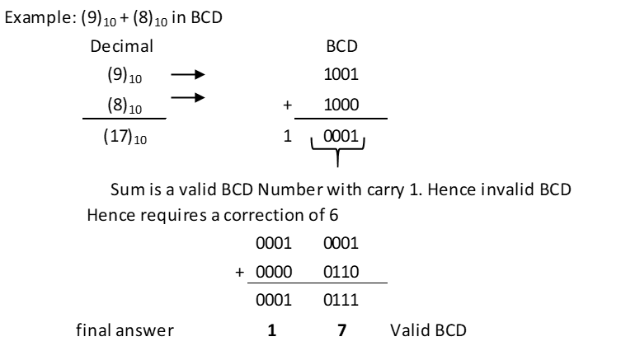

Practise Example of BCD Addition:

Key Take away
BCD Addition Rules:
Add the two numbers as in binary addition
If the 4-bit sum is equal to or less than 9,it is a valid BCD
If the 4-bit sum is greater than 9 or a carry is generated than it is invalid BCD and add 6 to the sum.

